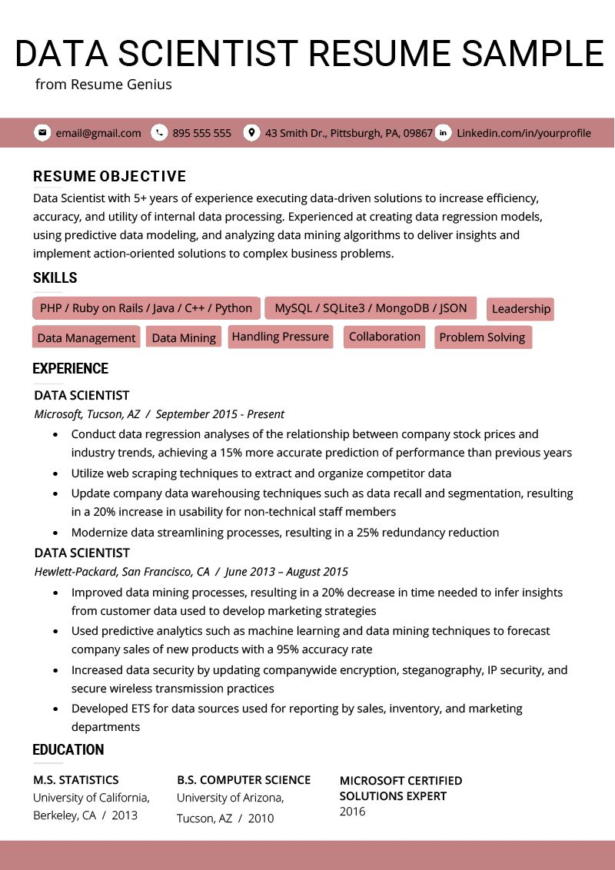
DATA SCIENTIST RESUME SAMPLE
from Resume Genius
email@gmail.com
895 555 555
43 Smith Dr., Pittsburgh, PA, 09867 in Linkedin.com/in/yourprofile
RESUME OBJECTIVE
Data Scientist with 5+ years of experience executing data-driven solutions to increase efficiency, accuracy, and utility of internal data processing. Experienced at creating data regression models, using predictive data modeling, and analyzing data mining algorithms to deliver insights and implement action-oriented solutions to complex business problems.
SKILLS
PHP/Ruby on Rails /Java/ C++ / Python
MySQL/SQLite3/MongoDB / JSON
Leadership
Problem Solving
Data Management Data Mining Handling Pressure Collaboration
EXPERIENCE
DATA SCIENTIST
Microsoft, Tucson, AZ / September 2015 - Present
·
Conduct data regression analyses of the relationship between company stock prices and industry trends, achieving a 15% more accurate prediction of performance than previous years
Utilize web scraping techniques to extract and organize competitor data
Update company data warehousing techniques such as data recall and segmentation, resulting in a 20% increase in usability for non-technical staff members
Modernize data streamlining processes, resulting in a 25% redundancy reduction
DATA SCIENTIST
Hewlett-Packard, San Francisco, CA / June 2013 - August 2015
• Improved data mining processes, resulting in a 20% decrease in time needed to infer insights from customer data used to develop marketing strategies
• Used predictive analytics such as machine learning and data mining techniques to forecast company sales of new products with a 95% accuracy rate
Increased data security by updating companywide encryption, steganography, IP security, and secure wireless transmission practices
• Developed ETS for data sources used for reporting by sales, inventory, and marketing departments
EDUCATION
M.S. STATISTICS University of California, Berkeley, CA 2013
B.S. COMPUTER SCIENCE
University of Arizona,
Tucson, AZ 2010
MICROSOFT CERTIFIED SOLUTIONS EXPERT 2016

